Modularity in artificial neural networks

Ricardo Téllez, r_tellez@ouroboros.org
Cecilio Angulo, cecilio.angulo@upc.edu
Knowledge Engineering Research Group
Technical University of Catalonia, Spain
INTRODUCTION
The concept of modularity is of great importance for the generation of artificially intelligent systems. Modularity is an ubiquitous organization principle found everywhere and at all levels in natural and artificial complex systems (Callebaut, 2005). Evidences from biological and philosophical points of view (Caelli and Wen, 1999)(Fodor, 1983), indicate that modularity is a requisite for complex intelligent behavior. Also, from an engineering point of view, modularity seems the only way for the construction of complex structures. This means that modularity is required if complex neural programs for complex agents are desired.
This article introduces the concepts of modularity and module from a computational point of view, and how they apply to the generation of neural programs based on modules. Two levels at which modularity can be implemented are identified, called strategic and tactical modularity. The article describes those two levels, how they work, and how they can be combined for the generation of a completely modular controller for a neural network based agent.
BACKGROUND
When creating a controller for the global behavior of a agent, there exist two main approaches: the monolithic approach, where a single module contains all the required behaviors of the agent, and the modular approach, where the global behavior is decomposed into a set of simpler sub-behaviors, each one implemented by one module. Monolithic controllers implement on a single module all the required mappings between the inputs and outputs of the agent. The advantage of this approach is that it is not necessary to identify which sub-behaviors are required for the controller or what are the relations between them. As a drawback, if the complexity of the controller is big, it may be impossible at practice to create such controller without obtaining great interferences between different parts of it. Instead, when a modular controller is used, the global controller is created by a group of sub-controllers, creating the necessity to determine which are the sub-controllers required and how should they combine for the generation of the final global output.
Despite the disadvantages of the modular approach, it is thought that complex behavior cannot be achieved if modularity is not introduced at some level (Boers, 1992)(Azam, 2000). A modular controller may allow the acquisition of new knowledge without forgetting previously acquired one, which represents a big problem for monolithic controllers when the number of different knowledge required to be learned is large. They also minimize the effects of the credit assignment problem, where the learning mechanism must provide a learning signal based on the current performance of the controller. This learning signal must be used to modify the controller parameters which will improve the controller behavior. In large controllers, it becomes difficult to find which parameter of the controller has to be changed based on the global learning signal. Modularization helps to keep the controllers small, minimizing the effect of the credit assignment.
Modular approaches allow for a complexity reduction of the task to be solved (De Jong et al., 2004). While in a monolithic system the optimization of all variables is performed at the same time resulting in a large optimization space, in modular systems, optimization is performed independently for each module resulting on a reduced searching space. Modular systems are scalable, in the sense that the use of modules allows the resolution of problems more and more complex by using the modules created for the generation of new ones, or just by adding new modules to the already existing ones. This also implies that modular systems are robust, since the damage on one module affects the module alone, resulting in a loss of the abilities given by that module, but keeping the whole system partially functioning. Modularity may lead to meaningful representations, where one each module represents one concept. It can also be a solution to the problem of neural interference (Di Ferdinando et al., 2000). Monolithic networks suffer from the phenomenon of interference. This phenomenon is produced when an already trained network losses part of its knowledge when it is retrained to perform a different task. This effect is called temporal crosstalk (Jacobs et al.,1991). The phenomenon also occurs when a monolithic network has to learn two or more different tasks at the same time. In this case, the effect is called spatial crosstalk (Jacobs,1990). Modular systems allow for the reuse of modules in different activities, without having to re-implement the function represented on each different task (De Jong et al., 2004)(Garibay, 2004).
Modularity
From a computational point of view, modularity is understood as the property that some complex computational tasks have to be divided into simpler subtasks. Then, each of those simpler subtasks is performed by a specialized computational system called a module, generating the solution of the complex task from the solution of the simpler subtask modules (Azam, 2000). From a mathematical point of view, modularity is based on the idea of a system subset of variables which may be optimized independently of the other system variables (De Jong et al., 2004). In any case, the use of modularity implies the existence of an structure in the problem to be solved.
In modular systems, each of the system modules operates primarily according to its own intrinsically determined principles. Modules within the whole system are tightly integrated but independent from other modules following their own implementations. They have either distinct or the same inputs, but generate their own response. When the interactions between modules are weak and modules act independently from each other, the modular system is called nearly decomposable (Simon, 1969). Other authors have identified this type of modular systems as separable problems (Watson et al., 1998). This is by far one of the most studied types of modularity, and it can be found everywhere from business to biological systems. In nearly decomposable modular systems, the final optimal solution of a global task is obtained as a combination of the optimal solutions of the simpler ones (the modules).
However, the existence of decomposition in one problem doesn't imply that the sub-problems are completely independent from each other. In fact, a system may be modular and still have interdependencies between modules. It is defined a decomposable problem as a problem that can be decomposed on other sub-problems but where the optimal solution of one of those problems depends on the optimal solution of some of the others (Watson, 2002). This implies that, even if there are different modules, strong interactions between them also exists. The resolution of such modular systems is more difficult than a typical separable modular system and is usually treated as a monolithic one in the literature. Most of the works on modularity for robot controllers only conceive the nearly decomposable description of modularity.
Module
Most of the works that use modularity, use the definition of module given by Fodor (Fodor, 1983), which is very similar to the concept of object in object oriented programming: a module is a domain specific processing element, which is autonomous and cannot influence the internal working of other modules. The only way a module can influence another is by its output, this is, the result of its computation. Modules do not know about a global problem to solve or global tasks to accomplish, and are specific stimulus driven. The final response of a modular system to the resolution of a global task, is given by the integration of the responses of the different modules by a especial unit. The global architecture of the system defines how this integration is performed. The integration unit must decide how to combine the outputs of the modules, to produce the final answer of the system, and it is not allowed to feed information back into the modules.
MODULAR NEURAL NETWORKS
When modularity is applied for the creation of a modular neural network (MNN) based controller, three general steps are commonly observed. Those are task decomposition, training and multi-module decision-making (Auda and Kamel, 1999). Task decomposition is about dividing the required controller into several sub-controllers, and assigning each sub-controller to one neural module. Then the modules should be trained either in parallel or in different processes following a sequence indicated by the modular design. Finally, when the modules have been prepared, a multi-module decision making strategy is implemented which indicates how all those modules should interact in order to generate the global controller response. This modularization approach can be seen as a modularization at the level of the task.
The previous general steps for modularity only apply for a modularization of nearly decomposable or separable problems. Decomposable problems, those where strong interdependencies between modules exist, are not contemplated under that decomposition mechanism, and are treated as monolithic ones. In order to solve that, this article proposes the differentiation between two modular levels, the current modularization level which concentrates on task sub-division, and a newly added modular level, where modularization is performed at the level of device or element. Those levels are called strategic and tactical, respectively.
Strategic and tactical modularity
Borrowing the concepts from game theory, we know that strategy answers the question of what has to be done in a given situation in order to perform a task, i.e., it divides the global target solution into all the sub-targets required to accomplish the global one. Tactics, on the other hand, answers the question of how the plans are going to be implemented, this means, how to use the resources available at that moment to accomplish each of those sub-targets. When those definitions are applied to the creation of a neural controller, strategy can be thought of as the overall group of sub-goals required for the accomplishment of a goal, and tactics as the actual means used to achieve each of those sub-goals. Thus, those definitions can be used to identify two levels of modularity in neural controllers: strategic modularity and tactical modularity.
We define strategic modularity in neural controllers as the modular approach that identifies which sub-goals are required for an agent in order to solve a global problem. Each sub-goal identified is implemented by a monolithic neural net. In contrast, we define tactical modularity in neural controllers as the one that identifies which inputs and outputs are necessary for the implementation of a given goal, and creates a single module for each input and output. In tactical modularity, modularization is performed at the level of the elements that are actually involved in the accomplishment of the task (by element, we understand any meaningful input or output of the neural controller).
To our extent, all the research based on neural modularity and divide-and-conquer principles, focus their division at the strategic level, that is, how to divide the global problem into its sub-goals. Then, they implement each of those sub-goals by means of a single neural controller, and generate the final goal by combining the outputs of those sub-goals in some sense. The current paper proposes, first, the definition of two different levels of modularity, and second, the use of tactical modularity as a new level of modularization that allocates space for decomposable modularity. It is expected that tactical modularization will be very helpful in the generation of complex neural controllers where several inputs and outputs have to be taken into account. This result will be confirmed below, where the use of the two types of modularity will be compared against monolithic approaches.
Implementing strategic modularity
Strategic modularity can be implemented by any of the modular approaches already existent in the literature. How to perform the sub-goals division has been widely studied in the literature. For a complete description see (Auda and Kamel, 1999). Any of the modularization methods described there implement strategic, and is in principle valid for its integration with tactical modularity.
In conclusion, strategic modularity has already been used for a number of years, although it was not given that name. We have used the term strategic for those modular approaches in order to differentiate them from the new level of modularity that we propose.
Implementing tactical modularity
Tactical modularity creates modularity at the level of the elements that participate in the generation of a sub-goal. By elements we understand the inputs required to generate the sub-goal, and the outputs that define the sub-goal solution. Each of those elements conform a tactical module. Each tactical module is implemented by a simple neural network. That is, tactical modularity is implemented by creating a completely distributed controller composed of small processing modules around each of the meaningful elements of the problem.
The schematics of a tactical module is shown in figure 1. There is one tactical module per each element. Tactical modules are connected to its associated element, controlling them, and processing the information that comes from them, for input elements, or that go to them, for output elements. This type of connectivity means that the processing element is the one that decides which commands must be sent to the output element, or how a value received from an input element must be interpreted. We say that the processing element is responsible for its associated element.
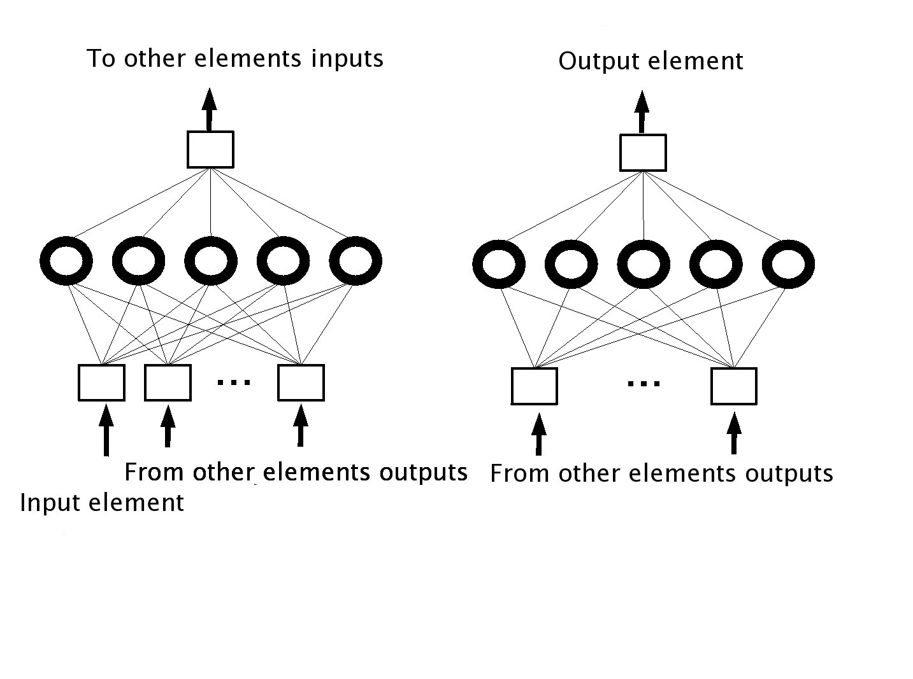
Figure 1. Schematics of a tactical module for one input element (left) and for one output element (right).
In order to generate a complete answer for the sub-goal, all the tactical modules are connected between each other, that is, the output of each module is sent back to all the others. By introducing this connectivity, each module is aware of what the others are doing. On top of that, it allows the different modules to coordinate for the generation of a common answer, avoiding the necessity of having a central coordinator. The resulting architecture shows a completely distributed MNN, where neural modules are independent but implement strong interactions with the other modules. Figure 2 shows a connectivity example in the generation of a tactically modular neural controller for a simple system composed of two input elements and two outputs.
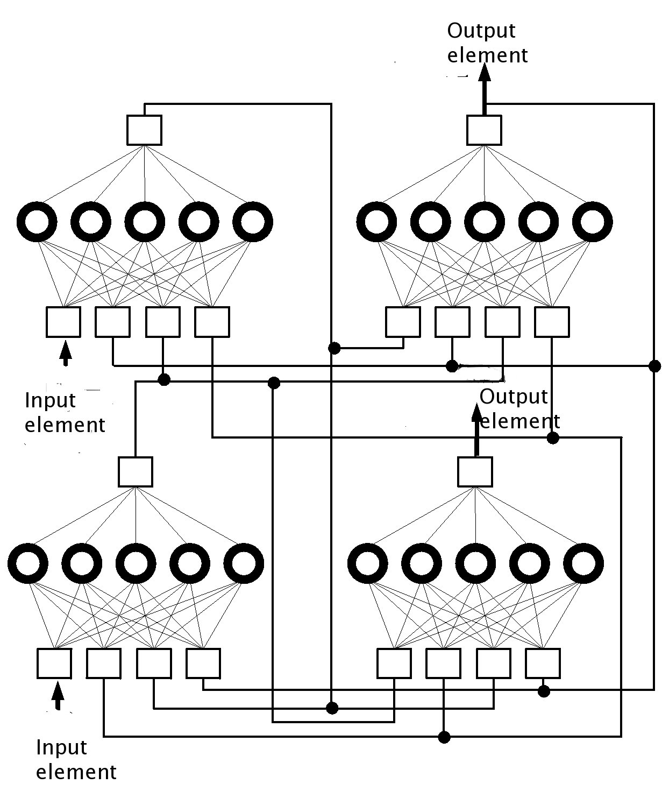
Figure 2. Connectivity of a tactically modular controller with two input elements and two output elements.
The training of the tactical modules is a difficult thing. Due to the strong relationships between the different modules, the training methods used in strategic modules based on error propagation (xxx), are not possible. Because of that, a genetic algorithm is used to train the nets. The genetic algorithm allows to find the networks weights without having to define an error measurement, just by specifying a cost function.
Combination of different levels
The use of one type of modularity does not prevent, in principle, the use at the same time of the other type of modularity. In fact, strategic and tactical modularity can be used separately or in conjunction with each other. When the solution required from the controller is simple, then either a strategic or a tactical modularization can in principle be used. In those cases, we suggest that the selection of modularity type be based on the complexity of the problem. If the problem is simple and the number of elements is low, then a monolithic controller will do it. If the number of elements is big, then a tactically modular controller may be the best option. When the task at hand is very complex and the number of elements is also big, then a combination of strategic and tactical modularization may be required.
When combining both levels in one neural controller, the strategic modularization should be performed first, to identify the different sub-goals that require implementation. Afterwards, a tactical modularization should be done, implementing each of those sub-goals by a group of tactical modules. The number of tactical modules for each strategic module will depend on the elements that participate in the resolution of the specific sub-goal.
Application examples
So far, we have concentrated to apply strategic and tactical modularity to robot control. In robot control the input elements are the sensors, and the output elements are the actuators. On a first experiment, we applied tactical modularity to the control of a Khepera robot learning to solve the garbage collector problem (Téllez and Angulo, 2006)(Téllez and Angulo, 2007). This involved the coordination of 11 elements (seven sensors and four actuators), creating 11 tactical modules. The task was compared with different levels of modularization, including monolithic, strategic, tactical and a combination of both. The results showed that the combination of both levels obtained the better results (see figure 3).
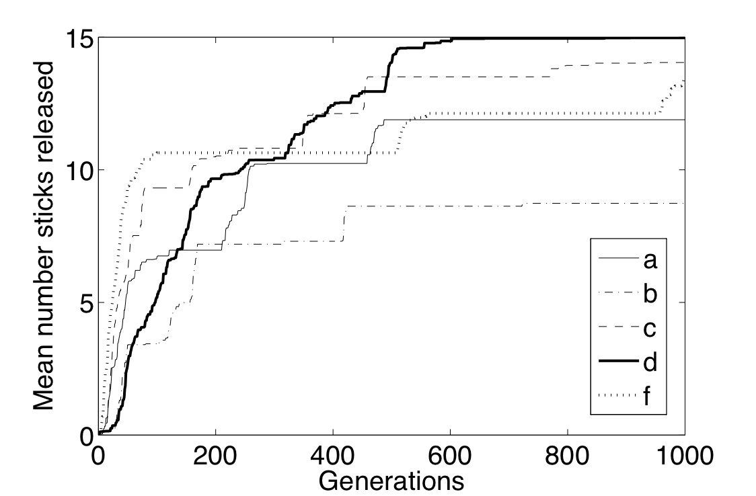
Figure 3. This figure represent the maximal performance value obtained by different types of modular approaches. Approach (a) is a monolithic approach, (b) and (c) are two different types of strategic approaches, (d) is tactical approach, and (f) is a reduced version of the tactical approach.
On additional experiments, tactical modularity was implemented into an Aibo robot. In this case, 31 tactical modules were required to generate the controller. The controller was generated to solve different tasks like stand up, standing and pushing the ground (Téllez et al., 2005). The controller was also able to generate one of the first MNNs controller able to make Aibo walk (Téllez et al., 2006).
FUTURE TRENDS
Within the evolutionary robotics paradigm, it is very difficult to generate complex behaviors when the robot used is quite complex with a huge number of sensors and actuators. The use of tactical modularity together with strategic one, is introduced as a possible solution to the problem of generating complex behaviors in complex robots. Even if some examples have been provided with a quite complex robot, it is necessary to see if the system can scale to systems with hundreds of elements.
Additional applications include its use in more classical domains like pattern recognition, speech recognition.
CONCLUSION
The level of modularity in neural controllers can be highly increased if tactical modularity is taken into account. This type of modularity complements typical modularization approaches based in strategic modularizations, by dividing strategic modules into their minimal components, and assigning one single neural module to each of them. This modularization allows the implementation of decomposable problems within a modularized structure. Both types of modularizations can be combined in order to obtain a highly modular neural controller, which shows better results in complex robot control.
REFERENCES
Auda, G. & Kamel, M. (1999), Modular neural networks: a survey, International Journal of Neural Systems, 9
Azam, F. (2000), Biologically inspired modular neural networks, PhD Thesis at theVirginia Polytechnic Institute and State University
Boers, E. & Kuiper, H. (1992), Biological metaphors and the design of modular artificial neural networks, Master Thesis, Leiden University
Caelli, G. L. & Wen, W. (1999), Modularity in neural computing, Proceedings of the IEEE
Fodor, J. (1983), The modularity of mind, The MIT Press
Callebaut, W. (2005), The ubiquity of modularity, Modularity. Understanding the Development and Evolution of Natural Complex Systems, The MIT Press
De Jong, E.D. and Thierens, D. and Watson, R.A. (2004), Defining Modularity, Hierarchy, and Repetition, Proceedings of the GECCO Workshop on Modularity, regularity and hierarchy in open-ended evolutionary computation
Di Ferdinando, A. Calabretta, R. and Parisi, D. (2000), Evolving modular architectures for neural networks, Proceedings of the sixth Neural Computation and Psychology Workshop: Evolution, Learning and Development
Jacobs, R.A. (1990), Task decomposition through competition in a modular connectionist architecture, PhD thesis, University of Massachusets
Jacobs, R.A. and Jordan, M.I. and Barto, A.G. (1991), Task decomposition through competition in a modular connectionist architecture: the what and where vision tasks, Cognitive Science,15 , 219-250
Simon, H.A., (1969) The sciences of the artificial, The MIT Press
Téllez, R.A. and Angulo, C. and Pardo, D. (2005), Highly modular architecture for the general control of autonomous robots, Proceedings of the 8th International Work-Conference on Artificial Neural Networks
Téllez, R.A. and Angulo, C. and Pardo, D. (2006), Evolving the walking behaviour of a 12 DOF quadruped using a distributed neural architecture, Proceedings of the 2nd International Workshop on Biologically Inspired Approaches to Advanced Information Technology
Téllez, R. and Angulo, C., (2006) Tactical modularity for evolutionary animats, Proceedings of the CCIA
Téllez, R. and Angulo, C. (2007), Acquisition of meaning through distributed robot control, Proceedings of the ICRA Workshop on Semantic information in robotics
Watson, R.A., Hornby, G.S. and Pollack, J. (1998), Modeling Building-Block Interdependency, Late Breaking Papers at the Genetic Programming 1998 Conference
Watson, R. (2002), Modular Interdependency in Complex Dynamical Systems, Proceedings of the 8th International Conference on the Simulation and Synthesis of Living Systems

TERMS AND DEFINITIONS

Neural controller: a computer program, based on artificial neural networks. The neural controller is a neural net or group of them which act upon a series of meaningful inputs, and generates one or several outputs.
Element: any variable of the program that contains a value that is used to feed into the neural network controller (input element) or to contain the answers of the neural network (output element). The input elements are usually the variables that contain the information from which the output will be generated. The output elements contain the output of the neural controller.
Modularization: it consists of identifying which sub-goals are required to complete a task.
Evolutionary robotics: a technique for the creation of neural controllers for autonomous robots, based on genetic algorithms.
Genetic algorithm: an algorithm that simulated the natural evolutionary process, applied the generation of the solution of a problem. It is usually used to calculate parameters difficult to calculate by other means (like for example the neural network weights). It requires the definition of a cost function.
Cost function: a mathematical function used to determine how good or how bad has a neural network performed during the training phase. The cost function usually indicates what is expected from the neural controller.

